**Name : SushilDalavi**

**Roll No : 19102A0044**

**Branch/Div : CMPN/A**

**Subject : Audit Course Level 1 Task.**

**Project Name : SkillZ**

|  |  |
| --- | --- |
| Front End Tools | HTML 5, CSS3 |
| Project Leader | Sushil Dalavi |
| Project Language | English |
| Country | India |
| Reference sites | www.udemy.com,www.coursera.com |
| Github Repository Link | https://github.com/priyankbagad/Audit-Course |

**Project Description :** SkillZ is an online learning website where people from any profession who are eager to enter the world of programming can fulfill their dreams . The whole intension of this project is being able to create a website stating that offers online learning courses for people from all walks of life to enjoy the world of programming. This is a part of an Audit Course named “Industry Ready Web Developer” in which I have used Basic HTML and CSS to create a raw layout of the website and futher improvisations are needed to make it more dynamic and ready to use which will be done as we approach futher levels. Below attached are the screenshots of the work done till now.

**Screenshots:**

**Signup page:-**

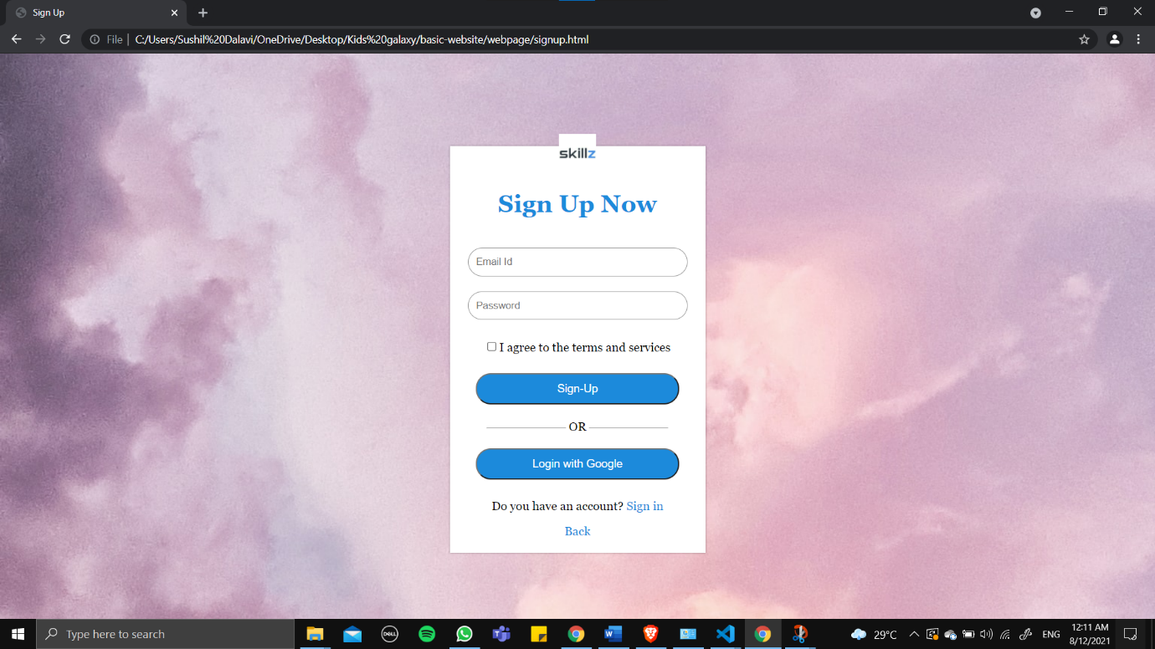

**Home page:-**

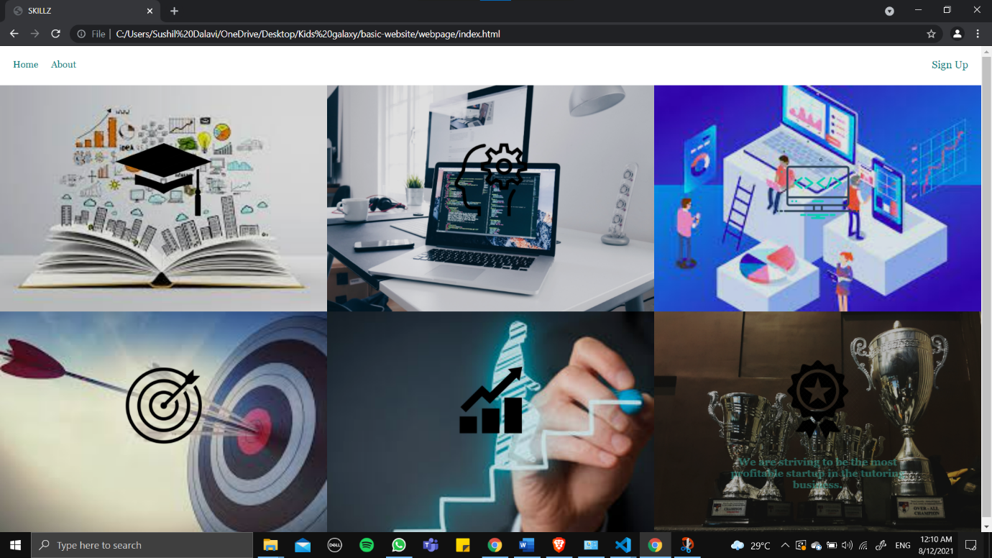

**About us page:-**

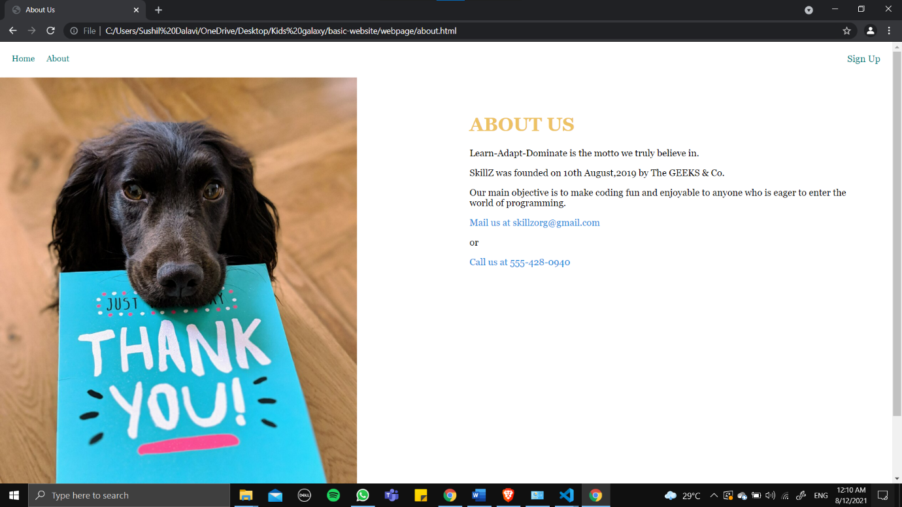

**Repository Link Here : https://github.com/sushildalavi/sushildalavi-SkillZ-Audit-Course-Kids-Galaxy-task1**